Project Design Phase-II
Data Flow Diagram & User Stories

Date | 21-10-2026
Team ID
Project Name | StaffSync
Maximum Marks | 4 Marks

Data Flow Diagrams:
A Data Flow Diagram (DFD) illustrates how workforce data flows across the StaffSync platform. It defines how organizational users (HR Personnel, Department Managers, and Employees) interact with core application processes, how information is validated and routed through controllers, and where data records are persisted in MongoDB collections.

DFD Level 0 & Level 1 — StaffSync HRM System
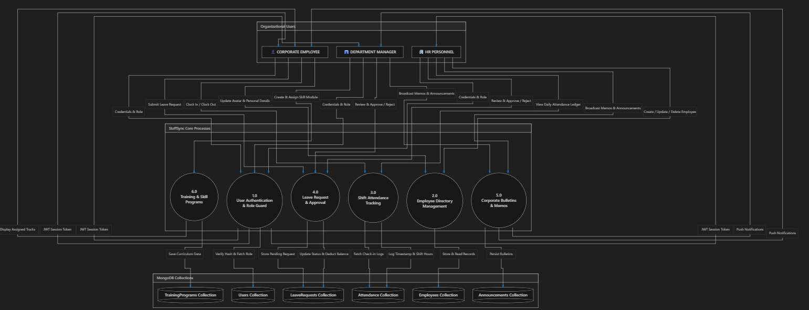

User Stories

User Story Table – StaffSync

User Type | Functional Requirement  (Epic) | User Story / Task | Acceptance Criteria | Priority | Release

HR  Personnel | Workforce  Directory | As an HR admin, I can add, edit, or remove  employee records in the company directory. | Changes persist in MongoDB immediately and  reflect across lists without page reload. | High | Sprint-  2
HR  Personnel | Attendance  Auditing | As an HR admin, I can inspect daily organization-  wide attendance records. | Ledger accurately displays employee names,  punch times, and shift statuses. | High | Sprint-  3
Department  Manager | Team Oversight | As a manager, I can view all employees assigned  to my specific department. | Roster filters out other departments and displays  active headcount. | High | Sprint-  2
Department  Manager | Leave Approval | As a manager, I can approve or reject pending  leave requests submitted by my team. | Decision status updates to approved/rejected  and reflects on employee's portal. | High | Sprint-  3
Corporate  Employee | Shift Punching | As an employee, I can clock in and out for my  shift with a single button click. | Current timestamp is logged; duration  calculated; progress bar updates. | High | Sprint-  3
Corporate  Employee | Leave Application | As an employee, I can submit a leave request  with dates, category, and reason. | Request enters pending queue; visible on  employee and supervisor dashboards. | High | Sprint-  3
Corporate  Employee | Profile  Customization | As an employee, I can update my personal profile  and upload a custom avatar picture. | Image URL/file updates in database and shows in  top navigation bar immediately. | Medium | Sprint-  2
All Users | Corporate  Communications | As an authorized user, I can send and read  corporate bulletins and internal memos. | Bulletins sync in real-time; priority badges (e.g.  URGENT) display correctly. | High | Sprint-  4
Department  Manager | Skill Development | As a manager, I can create training programs and  assign them to my department staff. | Program appears in assigned employees' training  lists with target dates. | Medium | Sprint-  4
All Users | Accessibility &  Localization | As a user, I can toggle the interface language  between English and Hindi. | UI labels and navigation items translate instantly  without page reloads. | Low | Sprint-  4

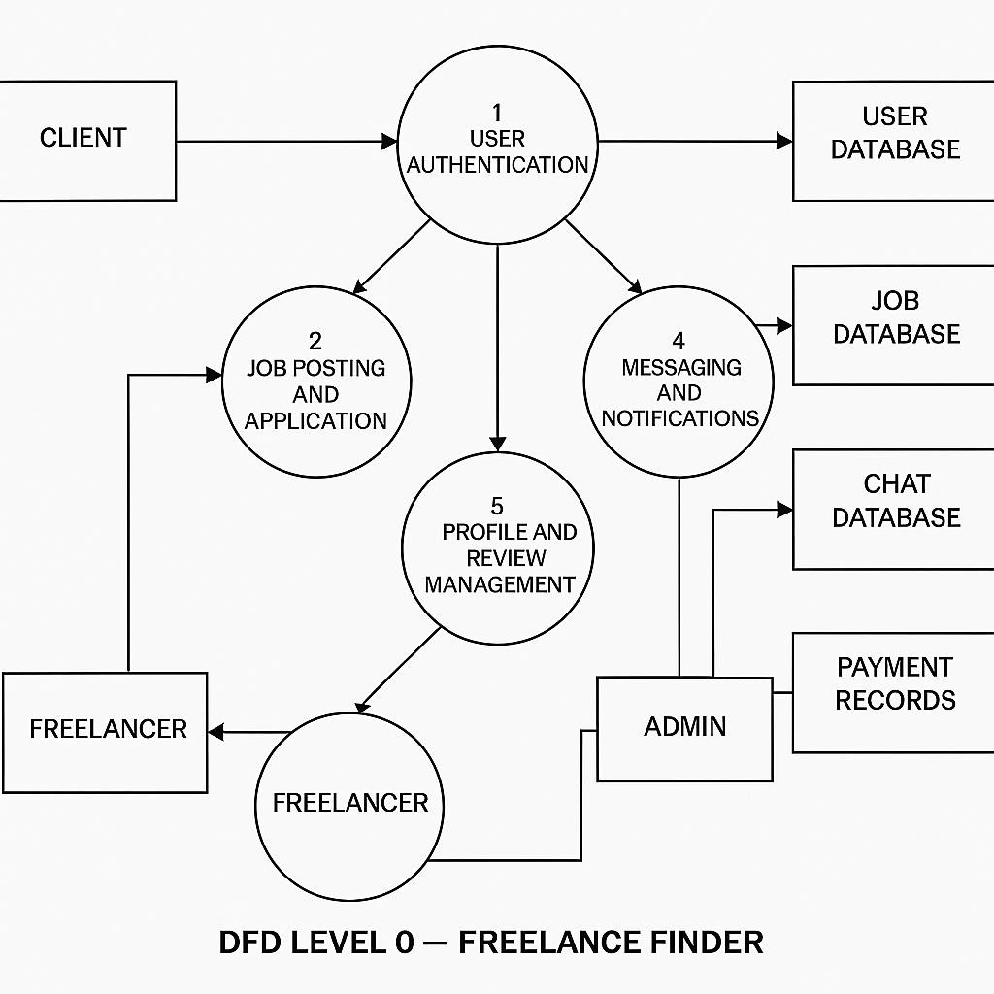

User Stories

User Story Table – Freelance Finder

User Type | Functional Requirement (Epic) | User Story / Task | Acceptance Criteria | Priority | Release
Client | Job Posting | As a client, I can post a new freelance job. | Job appears on homepage and my dashboard. | High | Sprint-1
 | Job Browsing | As a freelancer, I can browse and filter available job | Filter returns relevant results. | Medium | Sprint-2

Freelancer | Job Application | As a freelancer, I can apply to a job with a proposal. | Application visible to client. | High | Sprint-1
User | Messaging | As a user, I can chat with the other party in real-time. | Messages appear instantly. | Medium | Sprint-2
Freelancer | Profile Management | As a freelancer, I can update my profile and portfolio. | Changes are saved successfully. | High | Sprint-2
Client | Payment Processing | As a client, I can make secure payments after job completion. | Payment recorded and shown in transaction history. | High | Sprint-2
user | Review System | As a user, I can leave a review after project closure. | Review appears on profile. | Medium | Sprint-2
Admin | User Moderation | As an admin, I can review reported users and take action. | Reports and actions logged. | High | Sprint-1

